Team 41 Report

محمد أشرف سيد 2022170353
محمد متولي جميل 2022170384
عمرو محمد علي 2022170292
معاذ خالد عبد العزيز 2022170624
عمر حسن سعيد 2022170274
محمد عبد الرحمن احمد 2022170377

Design Patterns Used
1)- Singleton
Used to establish the Database Connection, So Connection is Opened once and not every part of the app opening its own connection.

2)- Factory
Used to Retrieve Suitable user object based on the selected Role
So, now the returned object depends on the selected option from the Role radio button, but independent of the logic of its creation itself .

3)- Strategy
Used to Handle Choosing the suitable user session handler for routing and initial data loading based on user role and info.
By applying it , now our navigation algorithms are interchangeable .

4)- Composite
Used in building our Menus and its categories, as it’s like a tree composition where our main menu is the root and the categories are the children and menu items are the leaves
( note: that its now expandable, so menu items can serve as sub menus that contains other submenus or menu items ) .

5)- Façade
The Façade pattern is applied at the architectural level to provide a simplified and unified interface to the business logic. Instead of exposing multiple complex subsystems, façade acts as a single-entry point through which higher-level components interact with the system

6)- Adapter
Used in payment to adapt different incompatible payment methods ( stride – wallet – cash, … ) to make payment unified as functionality however the method of payment works .

7)- Flyweight
Fly weight is used to improve our memory management by caching the loaded views once loaded, so to retrieve the view when requested instead of recreating it .

8)- State
The State pattern is used to manage Order behavior to change dynamically according to its current state. Instead of relying on complex conditional statements (if / switch) to determine the order’s status and valid transitions, each state is encapsulated as a separate class that represents a specific phase in the order process.

9)- Proxy
Proxy Pattern is applied in add to cart logic, where items added to cart should be from the same restaurant, so selected items need to be checked first before allowing it to be in cart .
Also, its constraints the quantity of each order not to be more than 5 per item, as it first checks on the hash of the item whether it exists on the cart or not, if exists, it checks on the quantity of the item.

Features
Customer Features
- Browse restaurants with filters and search
- View restaurant menus and details
- Add items to cart
- Place orders with multiple payment options
- Track order status in real-time
- Rate and review restaurants
- Manage profile, addresses, and payment methods

Restaurant Owner Features
- Manage restaurant profile and settings
- Add/edit/remove menu items
- View and manage incoming orders

Delivery Features
- View Ready For Delivery
- Accept and track deliveries
- Navigate to pickup/delivery locations
- Track earnings

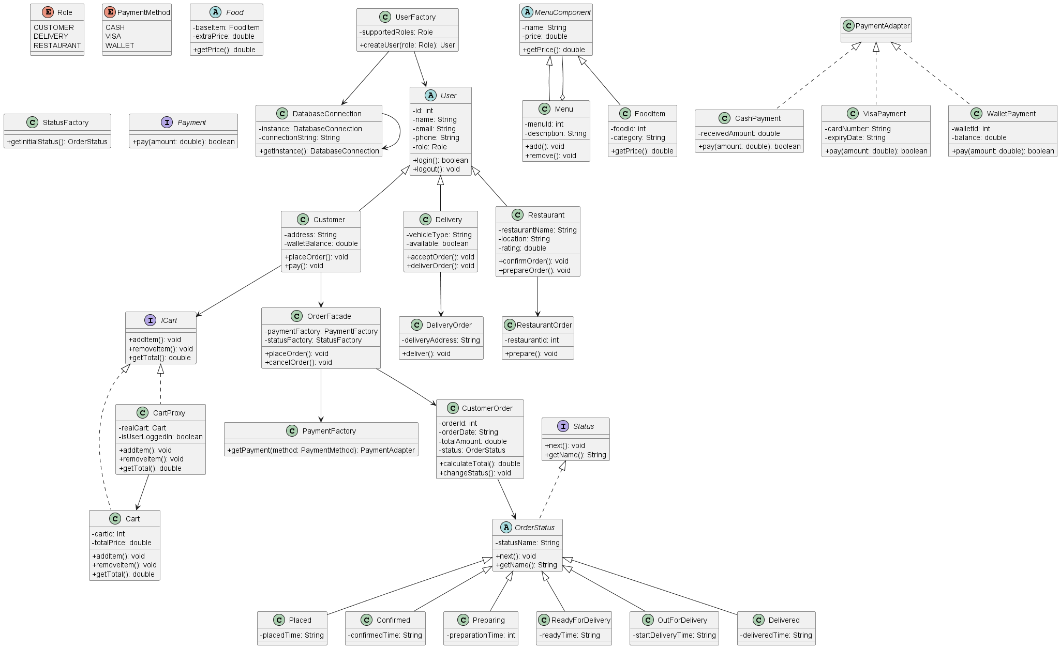
UML

